Week 4 — Final Capstone Report
Comprehensive Data Analysis Reporting and Presentation
An End-to-End Data Analytics Case Study: From Raw Data to Predictive Insight
Dataset: Titanic Passenger Survival Dataset
Prepared By | Oishi Das
Program | Data Analytics Internship — Final Report (Weeks 1-4)
Tool Used | R (v4.3.3) — tidyverse, ggplot2, caret, pROC, car, lattice
Dataset Source | Public dataset (Kaggle) — 891 records, 12 raw / 19 engineered variables
Scope | Data Cleaning -> Visualization -> Statistical Modeling -> Synthesis
Date | August 2026

Table of Contents
Executive Summary
1. Introduction
1.1 Project Background
1.2 Dataset Overview
1.3 Objectives Across the Four Weeks
2. Methodology Overview
3. Data Preparation and Cleaning (Week 1)
3.1 Outlier Treatment
3.2 Scaling and Encoding
3.3 Early Correlation Signal
4. Data Visualization and Insight Communication (Week 2)
4.1 The Gender and Class Story
4.2 The Age Effect, Visualized
4.3 Fare as a Within-Class Signal
4.4 Communicating to a Non-Technical Audience
5. Statistical Analysis and Predictive Modeling (Week 3)
5.1 Hypothesis Testing Results
5.2 Predictive Model: Logistic Regression
5.3 Model Validation and Performance
6. Discussion
6.1 Synthesis Across All Three Weeks
6.2 Statistical Significance vs Practical Importance
6.3 Hypothetical Business Implications
6.4 Limitations
7. Conclusion
7.1 Summary of Findings
7.2 Lessons Learned
7.3 Challenges Encountered
7.4 Future Directions
7.5 Complete Deliverables Across the Internship

Executive Summary
Over four weeks, this internship project took a single public dataset — 891 Titanic passenger records — through a complete, professional data analytics lifecycle: cleaning and preparing messy raw data, exploring and visualizing it for both technical and non-technical audiences, building and rigorously validating a predictive classification model, and finally, consolidating everything into this single narrative report. The consistent choice to retain one dataset across all four weeks was deliberate: it allowed each week's work to build cumulatively on the last, mirroring how a real analytics project moves from raw data to a validated, decision-ready model rather than restarting from scratch each time.
The core finding, arrived at independently through exploratory visualization (Week 2) and confirmed through formal hypothesis testing and predictive modelling (Week 3), is that passenger sex and socio-economic class (proxied by ticket class and fare) were the dominant drivers of survival, with age playing a smaller, non-linear role concentrated among young children. A logistic regression model built on these factors achieved 81.4% accuracy and a 0.86 AUC on unseen test data — a strong, well-validated result for a relatively simple, fully interpretable model.
This report is organized to mirror the analytics lifecycle itself: Introduction and Methodology, followed by three technical sections corresponding to Weeks 1-3 (Data Preparation, Visualization and Insight Communication, and Statistical Analysis and Predictive Modeling), then a Discussion synthesizing findings across all three, and a Conclusion covering lessons learned, challenges, and recommended next steps.

1. Introduction

1.1 Project Background
This report is the capstone deliverable of a four-week data analytics internship program, in which each week targeted a distinct stage of the analytics lifecycle using the R programming language: data cleaning (Week 1), data visualization (Week 2), statistical analysis and predictive modelling (Week 3), and — in this report — integration and communication of the complete body of work (Week 4).

1.2 Dataset Overview
The Titanic passenger dataset was selected in Week 1 and retained throughout the project. It records demographic and travel details for 891 passengers aboard the RMS Titanic, along with each passenger's survival outcome, and was chosen because it combines missing data of varying severity, a mix of categorical and numerical variables, and genuine outliers — the exact complexity profile needed to demonstrate a full, realistic cleaning-to-modelling pipeline.
Attribute | Detail
Source | Public dataset (Kaggle "Titanic: Machine Learning from Disaster")
Raw size | 891 rows x 12 columns
Cleaned size | 891 rows x 19 columns (post feature engineering)
Target variable | Survived (binary: 0 = No, 1 = Yes)
Predictor types | Categorical: Sex, Pclass, Embarked | Numerical: Age, Fare, SibSp, Parch

1.3 Objectives Across the Four Weeks
- Week 1: Clean and prepare the raw dataset — handle missing values, detect and treat outliers, normalize continuous variables, and encode categorical variables.
- Week 2: Design a suite of visualizations across multiple R plotting systems (ggplot2, base R, lattice) to communicate patterns and trends to both technical and non-technical audiences.
- Week 3: Formally test statistical hypotheses about the cleaned data and build, validate, and diagnose a predictive classification model.
- Week 4 (this report): Integrate all prior work into one cohesive narrative, discuss the combined implications of the findings, and reflect on lessons learned and future directions.

2. Methodology Overview
The project followed a linear, cumulative pipeline in which each week's output became the next week's input. This section summarizes that pipeline at a glance before the following three sections examine each stage in technical detail.
Stage | Week | Key Techniques | Primary Output
Data Preparation | 1 | Missing-value imputation, IQR outlier capping, min-max/z-score scaling, label/one-hot encoding | titanic_cleaned.csv (0 missing values)
Visualization | 2 | ggplot2, base R graphics, lattice — 10 chart types across bar/histogram/scatter/line/box/pie/dot plots | 10 annotated visualizations + narrative insights
Statistical Modeling | 3 | Shapiro-Wilk, chi-square, t-test, Wilcoxon, Spearman correlation, logistic regression, 10-fold CV | Validated classifier (81.4% accuracy, 0.86 AUC)
Integration | 4 | Cross-week synthesis, business framing, critical reflection | This report
All analysis was performed in R (v4.3.3). Reproducibility was treated as a first-class requirement throughout: every transformation and model was captured in version-controlled R scripts (analysis.R, visualize.R, model_analysis.R) rather than performed interactively and discarded, so that any step in the pipeline can be re-run end-to-end from the raw CSV.

3. Data Preparation and Cleaning (Week 1)
The raw dataset contained missing values in three columns of very different severity, requiring three distinct strategies rather than one blanket approach.
Column | Missing % | Strategy | Rationale
Cabin | 77.1% | Dropped; replaced with binary HasCabin flag | Too sparse to impute; flag preserves the signal that cabin-recording correlates with fare/class
Age | 19.9% | Group-wise median (by Pclass x Sex) | Age varies systematically by class and gender — a single global median would distort this
Embarked | 0.2% | Mode imputation | Only 2 rows affected; negligible bias from a simple mode fill
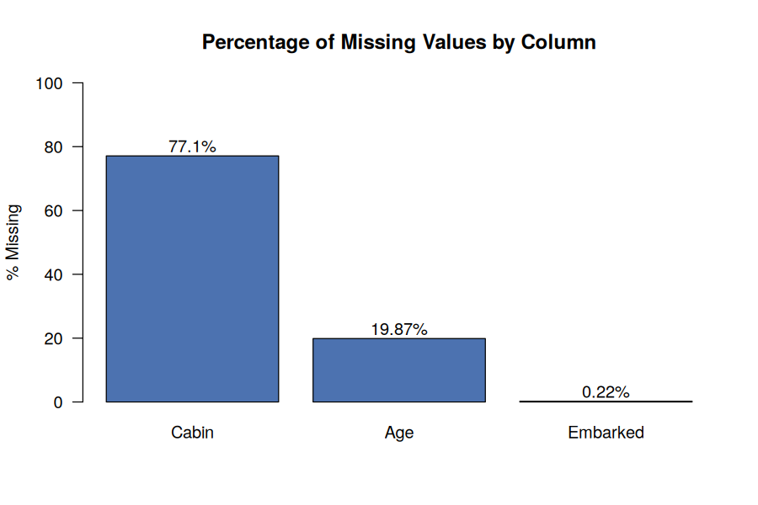
Figure 1. Missing value severity by column, prior to cleaning.

3.1 Outlier Treatment
The IQR method flagged 116 Fare outliers (13% of records) and 33 Age outliers. Rather than deleting these rows, Fare was Winsorized (capped at the upper IQR bound) to retain all 891 records while limiting the influence of extreme first-class fares on downstream statistics; Age outliers were left untouched, since elderly passengers up to 80 years old are plausible, valid data points rather than data-entry errors.
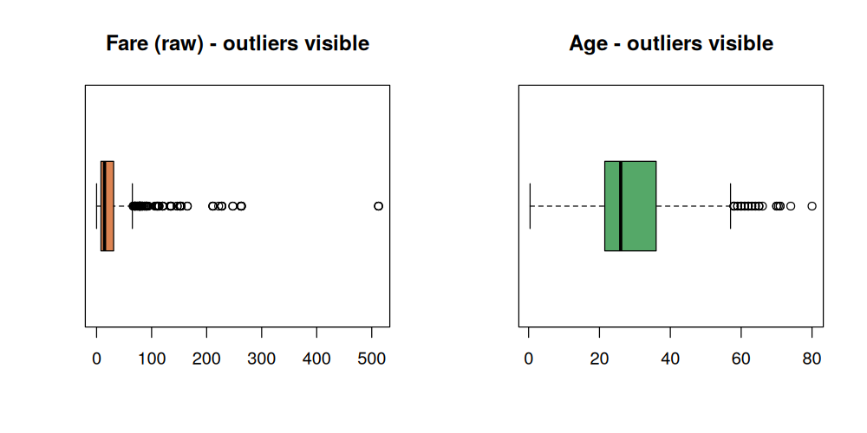
Figure 2. Boxplots showing Fare and Age outlier spread before treatment.

3.2 Scaling and Encoding
Continuous variables (Age, Fare) were normalized using both min-max scaling (0-1 range) and z-score standardization, kept as parallel columns for flexibility in later modelling. Sex was label-encoded (binary), while the three-level Embarked field was one-hot encoded to avoid implying a false ordinal relationship between ports.

3.3 Early Correlation Signal
Even before formal hypothesis testing in Week 3, a correlation matrix computed on the cleaned data hinted at the story that would later be confirmed statistically: Sex showed the strongest relationship with survival (r = -0.54), followed by Fare (r = +0.32), while Age showed a surprisingly weak linear relationship (r = -0.06) — a puzzle that Week 2's visualizations and Week 3's hypothesis tests would later help explain.
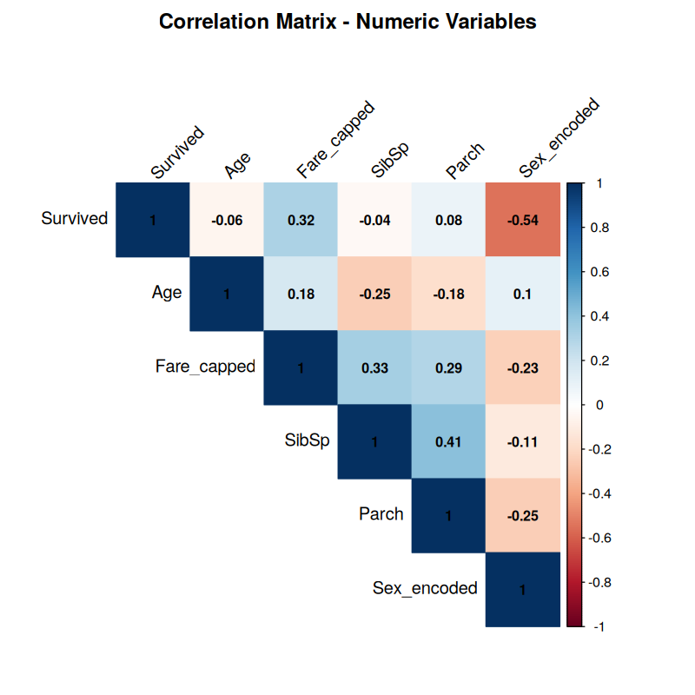
Figure 3. Correlation matrix across numeric/encoded variables (Week 1).

4. Data Visualization and Insight Communication (Week 2)
Building on the cleaned dataset, ten visualizations were developed across three R plotting systems (ggplot2, base R graphics, and lattice) to translate the numeric patterns from Week 1 into a form accessible to a non-technical audience. Rather than choosing chart types for variety alone, each was matched deliberately to the shape of the question it answered — bar charts for categorical comparisons, histograms for distribution shape, scatter plots for numeric relationships, a line chart for a trend across ordered age bands, and a lattice dot plot for a compact grouped comparison.

4.1 The Gender and Class Story
A faceted 100%-stacked bar chart made the combined effect of sex and class immediately visible: women survived at over 90% in 1st and 2nd class, dropping to 50% in 3rd class, while men's survival — far lower throughout — still roughly tripled between 3rd class (13.5%) and 1st class (36.9%).
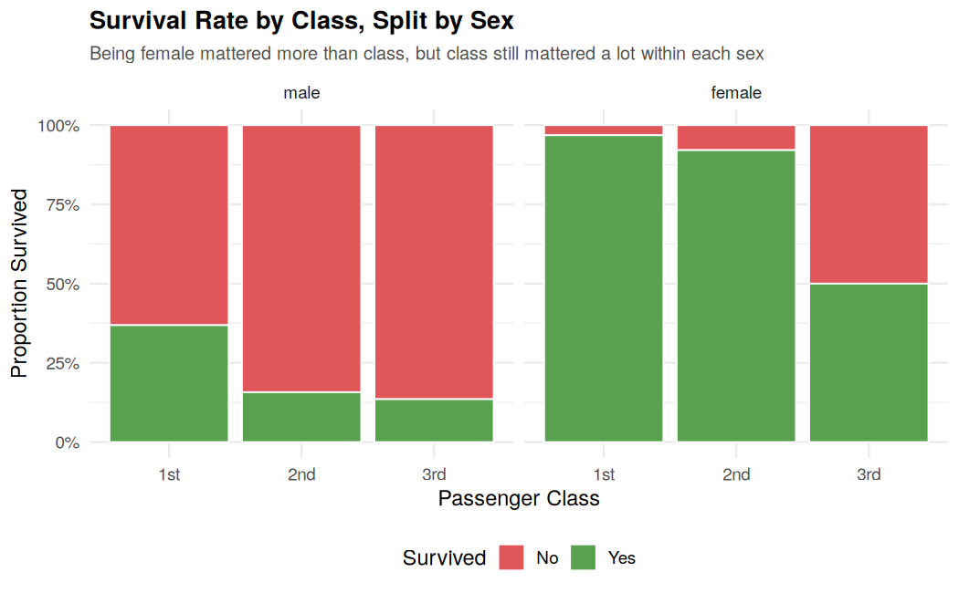
Figure 4. Survival rate by class, faceted by sex (Week 2).

4.2 The Age Effect, Visualized
A line chart of survival rate across 10-year age bands revealed the non-linear age pattern that the raw correlation coefficient in Week 1 had failed to capture: survival peaks at 59% for children aged 0-9 and generally declines with age thereafter, bottoming out at 20% for passengers in their 70s. This visualization directly explains why Age showed such a weak linear correlation with survival — the true relationship is concentrated at one end of the age range, not a smooth trend across it.
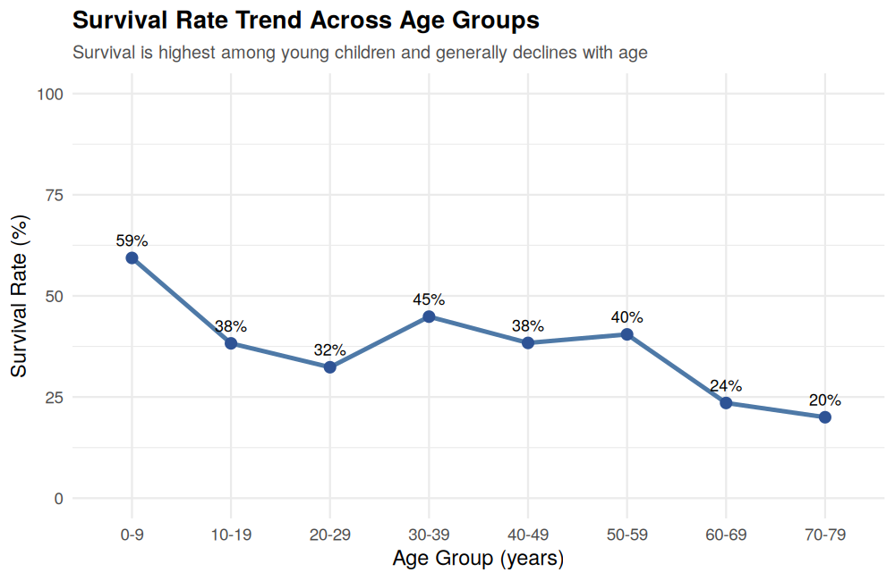
Figure 5. Survival rate trend across age groups (Week 2).

4.3 Fare as a Within-Class Signal
A scatter plot of Fare against Age, faceted by class and colored by survival, showed that the fare-survival relationship holds even within a single class — passengers who paid toward the higher end of their class's fare range survived more often than their same-class peers, suggesting fare captures additional information (e.g., cabin location, family purchasing power) beyond class alone.
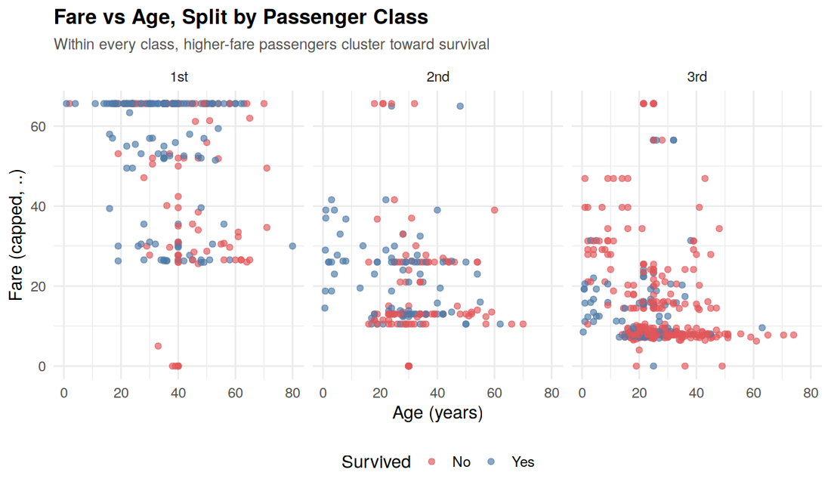
Figure 6. Fare vs Age by class, colored by survival (Week 2).

4.4 Communicating to a Non-Technical Audience
Every visualization in Week 2 was paired with a plain-language insight statement, deliberately avoiding statistical jargon (e.g., "women survived at roughly four times the rate of men" rather than reporting a raw correlation coefficient). This framing choice is itself a key finding of the project: the same underlying pattern (r = -0.54 for Sex) can be communicated either as an abstract statistic for a technical reviewer or as a concrete, memorable comparison for a general audience — and the latter is what drives stakeholder understanding and buy-in in a real business setting.

5. Statistical Analysis and Predictive Modeling (Week 3)
Week 3 moved from visual pattern-spotting to formal statistical confirmation and predictive modelling, closing the loop on questions raised by the earlier exploratory work.

5.1 Hypothesis Testing Results
Test | Variables | Result | Decision
Chi-square | Survival x Sex | p < 2.2e-16 | Reject H0 — significant association
Chi-square | Survival x Pclass | p < 2.2e-16 | Reject H0 — significant association
Welch t-test | Age by Survival | p = 0.082 | Fail to reject H0 — no significant mean difference
Wilcoxon rank-sum | Fare by Survival | p < 2.2e-16 | Reject H0 — significant distribution difference
Spearman correlation | Age vs Fare | p < 0.001, rho = 0.174 | Reject H0 — weak but significant association
The Welch t-test result is the most instructive finding of the week: it shows that mean age does not differ significantly between survivors and non-survivors, which at first appears to contradict Week 2's age-trend line chart. In fact, the two results are complementary rather than contradictory — the survival advantage is concentrated specifically among young children, and this localized effect washes out when comparing whole-group averages rather than age bands. This is a clear demonstration of why visual exploration and formal hypothesis testing serve different, complementary roles in an analysis.

5.2 Predictive Model: Logistic Regression
A logistic regression classifier was trained to predict survival from class, sex, age, family size, fare, and embarkation port, using 10-fold cross-validation on an 80% training split and final evaluation on a fully held-out 20% test set.
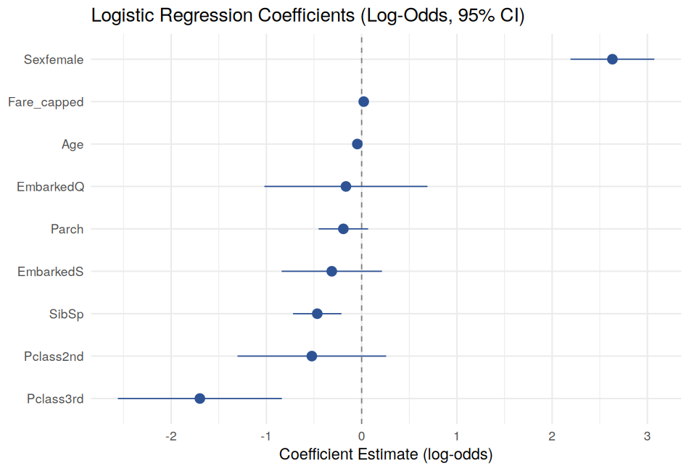
Figure 7. Logistic regression coefficients (log-odds, 95% CI) — Week 3.
Sex emerged as the single strongest predictor (log-odds +2.63, equivalent to roughly 13.9x higher survival odds for women, holding other factors constant), with 3rd class as the strongest negative predictor (log-odds -1.70). A variance inflation factor check confirmed no problematic multicollinearity among predictors, meaning these individual effect sizes can be trusted.

5.3 Model Validation and Performance
Metric | Cross-Validation (Train) | Held-Out Test Set
AUC / ROC | 0.851 | 0.860 (95% CI: 0.799-0.922)
Accuracy | — | 81.4%
Sensitivity | 87.0% | 64.7%
Specificity | 70.8% | 91.7%
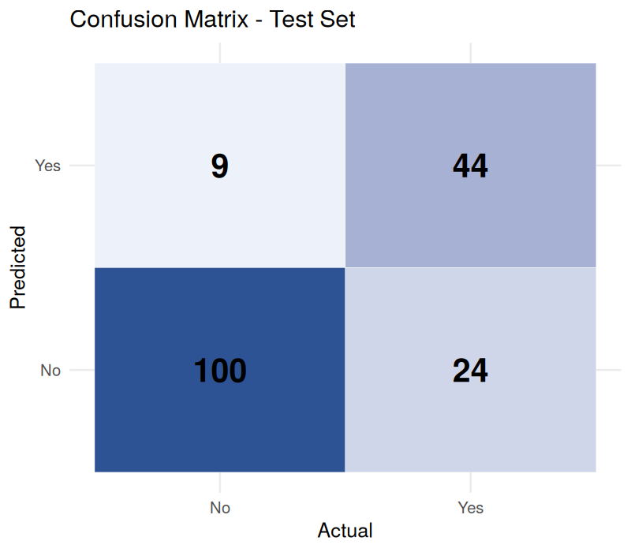
Figure 8. Confusion matrix on the held-out test set (Week 3).
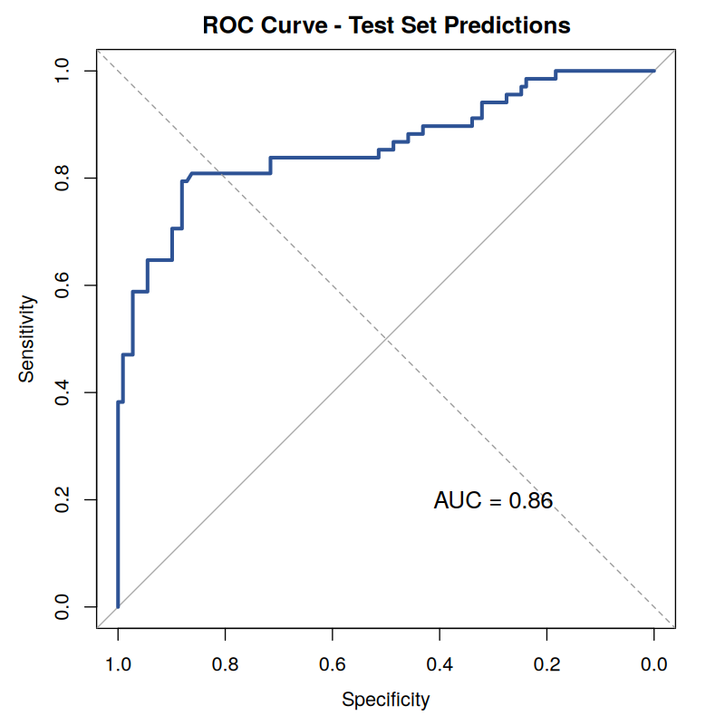
Figure 9. ROC curve, test set AUC = 0.860 (Week 3).
The close agreement between the cross-validated training AUC (0.851) and the held-out test AUC (0.860) is strong evidence the model generalizes well rather than overfitting. The model's main limitation — sensitivity of only 64.7% versus specificity of 91.7% — means it is conservative: it correctly identifies most non-survivors but misses roughly a third of actual survivors, a trade-off that would need to be revisited depending on the intended real-world use of the model.

6. Discussion

6.1 Synthesis Across All Three Weeks
Read together, the three technical weeks tell one consistent, mutually reinforcing story rather than three separate analyses. Week 1's correlation matrix first flagged Sex and Fare as the strongest signals; Week 2's visualizations made those signals vivid and explained the puzzling weak age correlation as a non-linear, children-specific effect; and Week 3 then closed the loop by statistically confirming exactly these relationships and building a validated model around them. This progression — numeric hint, visual explanation, statistical confirmation — mirrors how a real analytics engagement should move from raw exploration to defensible, decision-ready conclusions.

6.2 Statistical Significance vs Practical Importance
Several predictors were statistically significant (e.g., Fare at p = 0.0165 in the logistic regression) without being practically large in effect size, while others (Sex, 3rd class) were both highly significant and practically large. This distinction matters for any business application: statistical significance alone does not guarantee a factor is worth acting on, and this project's approach — reporting both p-values and effect sizes (log-odds, correlation coefficients) throughout — was designed specifically to avoid that common analytical trap.

6.3 Hypothetical Business Implications
Although the Titanic dataset itself is historical, the analytical pattern it demonstrates generalizes directly to a modern business setting — for example, a customer-churn or insurance-risk model: identifying that a small number of strongly predictive factors (analogous to Sex and Class here) drive most of the outcome variance, while other seemingly plausible factors (analogous to Embarked and Parch here) turn out to be statistically weak once the stronger predictors are already accounted for, allows a business to focus data-collection and intervention effort where it will actually move outcomes.

6.4 Limitations
- Sample size (891) is workable but modest for a classification task with 8+ predictors — a larger dataset would allow more confident subgroup analysis (e.g., age effects within each class).
- The model assumes linear, additive effects on the log-odds scale; the confirmed non-linear age effect (Section 5.1) suggests this assumption is imperfect and understates the true importance of age for a specific subgroup (young children).
- Historical, single-event data limits how far any conclusions can be generalized to other contexts without independent validation.

7. Conclusion

7.1 Summary of Findings
This four-week project took a single, moderately complex dataset through a complete, professional analytics pipeline. The consistent finding across every stage — correlation analysis, visual exploration, formal hypothesis testing, and predictive modelling — was that passenger sex and socio-economic class (via ticket class and fare) were the dominant, statistically robust drivers of survival, while age contributed a smaller, non-linear effect concentrated among young children. The final logistic regression model achieved 81.4% test accuracy and a 0.86 AUC, a strong result for a fully interpretable model with no evidence of overfitting.

7.2 Lessons Learned
- Cleaning decisions ripple forward: the choice to cap rather than delete Fare outliers in Week 1 directly shaped the Fare_capped variable used in every subsequent week's analysis and model — small early decisions compound across a pipeline.
- Visual and statistical methods answer different questions: Week 2's line chart and Week 3's t-test appeared to disagree about age's role in survival, but were in fact both correct at different levels of granularity — a reminder that no single technique tells the whole story.
- Model diagnostics are as important as model metrics: the VIF check and residual diagnostics in Week 3 didn't change the headline accuracy number, but they were essential to trusting that the individual coefficients (and therefore the business narrative built on them) were reliable rather than artifacts of multicollinearity or poor fit.

7.3 Challenges Encountered
- Balancing outlier treatment: deciding to cap rather than delete Fare outliers required weighing statistical cleanliness against the risk of discarding genuine, informative extreme values — resolved by choosing a treatment that preserved all data points.
- Reconciling the age paradox: the initial weak linear correlation for Age (Week 1) appeared to suggest age was unimportant, and only became fully understood after both a visual (Week 2) and a formal statistical (Week 3) investigation confirmed the effect was real but non-linear and localized.
- Communicating technical rigor to different audiences: ensuring the same underlying finding could be presented as a rigorous log-odds coefficient for a technical reviewer and as a plain, memorable comparison for a non-technical stakeholder required deliberate, separate framing rather than reusing one write-up for both audiences.

7.4 Future Directions
- Feature engineering: extract passenger titles (Mr/Mrs/Master/Miss) from the Name field and construct a combined FamilySize variable to better capture the non-linear age and family-size effects surfaced in this project.
- Alternative models: compare the logistic regression baseline against tree-based methods (Random Forest, XGBoost) or add explicit interaction terms (e.g., Sex x Pclass) to test whether non-linear modelling meaningfully improves on the current 0.86 AUC.
- Threshold and cost-sensitivity tuning: given the model's lower sensitivity (64.7%) than specificity (91.7%), future work should explore adjusting the classification threshold or applying class-weighted loss functions if correctly identifying survivors is prioritized over avoiding false alarms.
- External validation: apply the same cleaning-visualization-modelling pipeline to a second, independent dataset to test how well the methodology (rather than just this specific model) generalizes.

7.5 Complete Deliverables Across the Internship
Week | Report | Script(s) | Key Outputs
1 | Week1_Data_Cleaning_R_Report.docx | analysis.R | titanic_cleaned.csv, 7 visualizations
2 | Week2_Data_Visualization_R_Report.docx | visualize.R | 10 visualizations across 3 R plotting systems
3 | Week3_Statistical_Analysis_Predictive_Modeling_R_Report.docx | model_analysis.R | Validated logistic regression model, 5 hypothesis tests
4 | This report | — | Full cross-week synthesis and business discussion

